ACDC Cardiac MRI Classification Progress Report
1. Problem Statement
The goal of this project is to classify cardiac MRI patients into five diagnostic categories: Dilated Cardiomyopathy (DCM), Hypertrophic Cardiomyopathy (HCM), Myocardial Infarction (MINF), Normal (NOR), and Abnormal Right Ventricle (RV).
We initially proposed working with the VinDr-CXR chest X-ray dataset. However, due to its large storage requirements and our limited available storage, we switched to the ACDC (Automated Cardiac Diagnosis Challenge) dataset. This dataset is more manageable and provides cardiac MRI images, expert segmentation masks, and diagnostic labels.
Our approach focuses on extracting cardiac measurements from the MRI images and using them to classify patients. We also investigate how replacing expert segmentation masks with automatically predicted masks affects classification performance.
2. Data Preprocessing
The ACDC dataset contains 150 patients, with 100 in the official training set and 50 in the official test set. The patients are evenly distributed across the five diagnostic classes.
For each patient, we use the end-diastolic (ED) and end-systolic (ES) MRI frames, identified using the provided patient information files. The MRI volumes and their corresponding segmentation masks are loaded from NIfTI files.
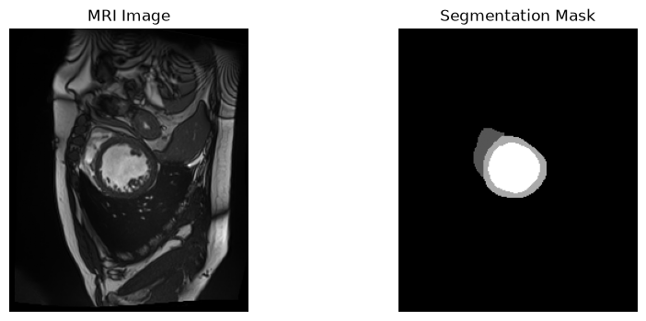
For classification, we extract seven cardiac measurements:
- Left ventricular volume at ED and ES (LV_ED, LV_ES)
- Right ventricular volume at ED and ES (RV_ED, RV_ES)
- Myocardial volume at ED (MYO_ED)
- Left and right ventricular ejection fractions (LV_EF, RV_EF)
Volumes are calculated by counting the voxels belonging to each cardiac structure and multiplying by the physical voxel volume. Ejection fraction is calculated from the difference between ED and ES volumes relative to the ED volume.
For automatic segmentation, each MRI slice is standardized using its mean and standard deviation. We extract five pixel-level features: normalized intensity, normalized horizontal and vertical coordinates, and local mean intensities using 3×3 and 7×7 filters. Pixels are sampled from each segmentation class to train the Random Forest without using every pixel in the dataset.
The 100 official training patients are divided into 80 training and 20 validation patients, with stratification by diagnostic class. The 50 official test patients are kept separate during model development.
3. Evaluation Metrics
We use classification accuracy and macro-F1 score to evaluate disease classification.
Accuracy measures the proportion of correctly classified patients. Macro-F1 calculates the F1 score for each diagnostic class and averages them equally, allowing us to evaluate performance across all five conditions rather than relying only on overall accuracy.
We also use classification reports and confusion matrices to examine which cardiac conditions are correctly classified and which are confused with one another.
For segmentation, we use the Dice similarity coefficient, which measures the overlap between predicted segmentation masks and expert masks. Dice scores are calculated separately for the right ventricle, myocardium, and left ventricle. This helps us evaluate segmentation quality and understand its effect on the cardiac measurements used for classification.
4. Classical Baseline
We developed two classical approaches based on Logistic Regression and Random Forest.
Model 1: Logistic Regression using expert segmentation masks
Our first approach uses the seven cardiac measurements extracted directly from the expert segmentation masks. We standardize these features and train a Logistic Regression classifier.
We tune the regularization parameter using five-fold cross-validation on the 100 training patients. The selected value is C = 1.0, achieving a mean cross-validation macro-F1 of approximately 0.9294.
This model serves as a reference for classification performance when accurate cardiac measurements are available.
Model 2: Random Forest segmentation followed by Logistic Regression
Our second approach replaces the expert masks with automatically predicted segmentation masks. A Random Forest classifier predicts the segmentation label of each MRI pixel using the five pixel-level features. We then extract the same seven cardiac measurements from the predicted masks and pass them to a Logistic Regression classifier.
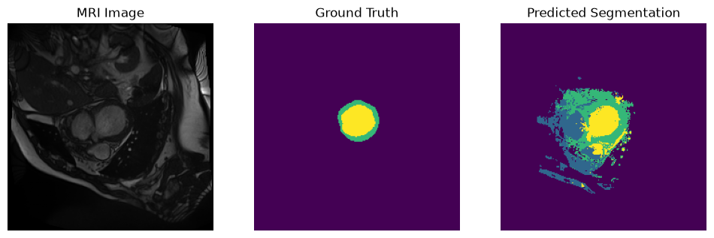
The selected Random Forest uses 100 trees, a maximum depth of 20, and a minimum leaf size of 2.
On the 20 validation patients, the segmentation model achieved the following mean Dice scores:
Structure | Mean Dice
Right ventricle | 0.3169
Myocardium | 0.3378
Left ventricle | 0.5589
Overall | 0.4046
Using the measurements extracted from these predicted masks, the classification pipeline achieved 30% validation accuracy and a macro-F1 of 0.1668.

The results show that the Random Forest struggles to segment the cardiac structures accurately, particularly the right ventricle and myocardium. This produces unreliable cardiac volumes and ejection fractions, reducing classification performance. Another limitation is that the Logistic Regression classifier is trained using measurements from expert masks but evaluated using measurements from predicted masks.
Despite its limitations, this approach provides a classical automatic-segmentation baseline against which more advanced methods can be compared.
5. Sophisticated Model: 2D U-Net Segmentation
Model: a 2D U-Net (four down/up-sampling levels, 16 base filters, BatchNorm, 1.94 M parameters) segments each short-axis slice into background/RV/myocardium/LV. It is trained on the same 80 patients with cross-entropy + soft-Dice loss (AdamW, cosine schedule, 40 epochs, 3.4 min on a GPU). Predicted ED/ES masks go through the same feature extraction and the same Logistic Regression, so only the segmenter changes. Optional post-processing keeps the largest 3D connected component per structure and is used only if it raises validation Dice (it did, but only by 0.0006, so its effect is negligible).
The Random Forest treats pixels independently using five hand-crafted local features, whereas the U-Net learns multi-scale features with a large receptive field and, through skip connections, shape context; the Dice term handles class imbalance directly instead of distorting the class priors. U-Nets are the standard approach for cardiac MRI segmentation.
Current progress and preliminary results: the U-Net is implemented, trained and evaluated (Table 1, Figure 2). It raises mean validation Dice from 0.405 to 0.907 (RV 0.887, myocardium 0.881, LV 0.954) and the pipeline accuracy / macro-F1 from 0.30 / 0.167 to 0.70 / 0.693, against 0.85 / 0.852 with expert masks. The error of the seven measurements drops by an order of magnitude (e.g. RV_ED mean absolute error 236 → 10 mL; correlation of LV_ED with the expert value 0.997), with the RV ejection fraction still the weakest (error 8 points, r = 0.88). After fixing all choices on validation, one evaluation on the 50 test patients gives Dice 0.927 and accuracy / macro-F1 0.86 / 0.860, versus 0.90 / 0.900 for expert masks and 0.28 / 0.163 for the Random Forest. The gap to the upper bound is two patients, so we do not claim a real difference; validation (0.70) and test (0.86) accuracy of the same pipeline differ by more than that, showing how noisy a 20-patient split is. Is a more complex classifier worth it? On expert-mask features (repeated 5-fold CV macro-F1) LR scores 0.926 ± 0.060, the best of three MLP settings 0.939 ± 0.043 (within one standard deviation, and selected among several settings), Random Forest 0.861 and Gradient Boosting 0.794, so no. Cost of the U-Net: 1.94 M parameters (versus 40 for LR), a GPU (3.4 min training, ≈0.04 s inference per patient) and much lower interpretability; the gain is large for segmentation and for the full pipeline (0.28 → 0.86 test accuracy), which is what the extra complexity buys.
Pipeline | Mean Dice: val (test) | Val acc / macro-F1 | Test acc / macro-F1
Model 1: expert masks LR (upper bound) | – | 0.85 / 0.852 | 0.90 / 0.900
Model 2: Random Forest masks LR | 0.405 (0.407) | 0.30 / 0.167 | 0.28 / 0.163
Model 3: U-Net masks LR | 0.907 (0.927) | 0.70 / 0.693 | 0.86 / 0.860
Table 1: Validation (20 patients, same 80/20 split for all pipelines) and held-out test (50 patients, evaluated once) results; Model 1 CV macro-F1 is 0.929.
6. Remaining Plan and Risks (until November 20)
- Failure analysis: Dice by structure, slice position (apical/basal slices), disease group and patient; trace segmentation error → volume/EF error → misclassification; inspect the worst cases. Mitigations to evaluate: largest-component post-processing (implemented), training the classifier on out-of-fold predicted-mask features to remove the train/test mismatch, and stronger augmentation.
- Complexity analysis: parameters, training/inference time and hardware for LR, Random Forest and U-Net; accuracy gain per unit cost; interpretability (LR coefficients vs. black-box U-Net).
- Sensitivity and final run: repeat with several training seeds (only one so far) and splits and report mean ± std or bootstrap intervals; retrain on all 100 training patients, evaluate once on the 50 test patients, and publish code and trained weights on GitHub.
- Risks: very small data (20 validation / 50 test patients) gives high-variance estimates; conclusions depend on a single LR trained on expert features; a 2D slice-wise model ignores inter-slice context (apical/basal slices likely worst); the fixed 160×160 crop could cut off the heart in unusual images (we measure the fraction of expert voxels kept); limited GPU time restricts multi-seed runs. Early observations: Random Forest errors are scattered false positives and inflated RV volumes; the U-Net is weakest on the RV and myocardium (Dice 0.887 / 0.881 vs 0.954 for the LV) and its remaining errors are mostly DCM ↔ MINF confusions, which the expert-mask LR also makes.
Figure 1: Initial Random Forest (intensity + position features) on a validation slice (MRI, expert mask, prediction): scattered false-positive RV and myocardium regions.
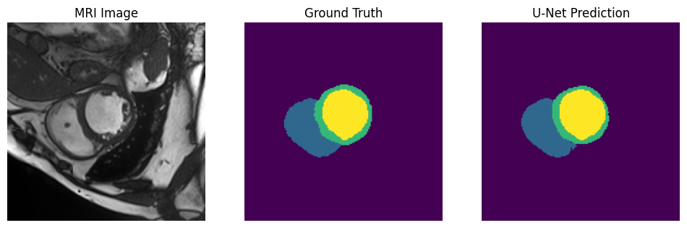
Figure 2: U-Net on the same validation patient (MRI, expert mask, prediction): the prediction closely matches the expert mask.

